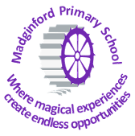

What Does a ‘Jigsaw’ PSHE Lesson at Madginford Primary School Include?
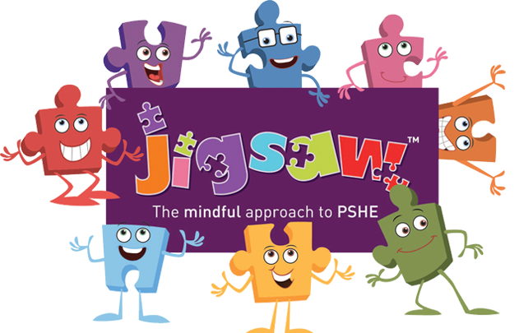

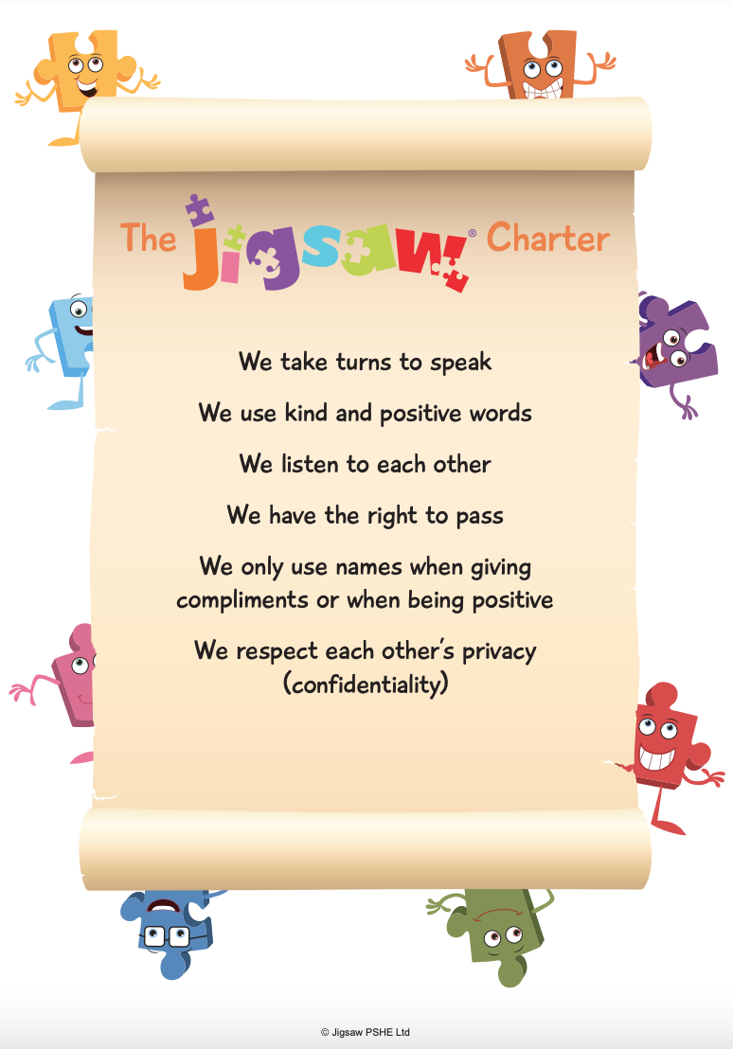
At the start of each lesson, the learning objectives, key vocabulary and Jigsaw charter are shared with the children.
Calm me
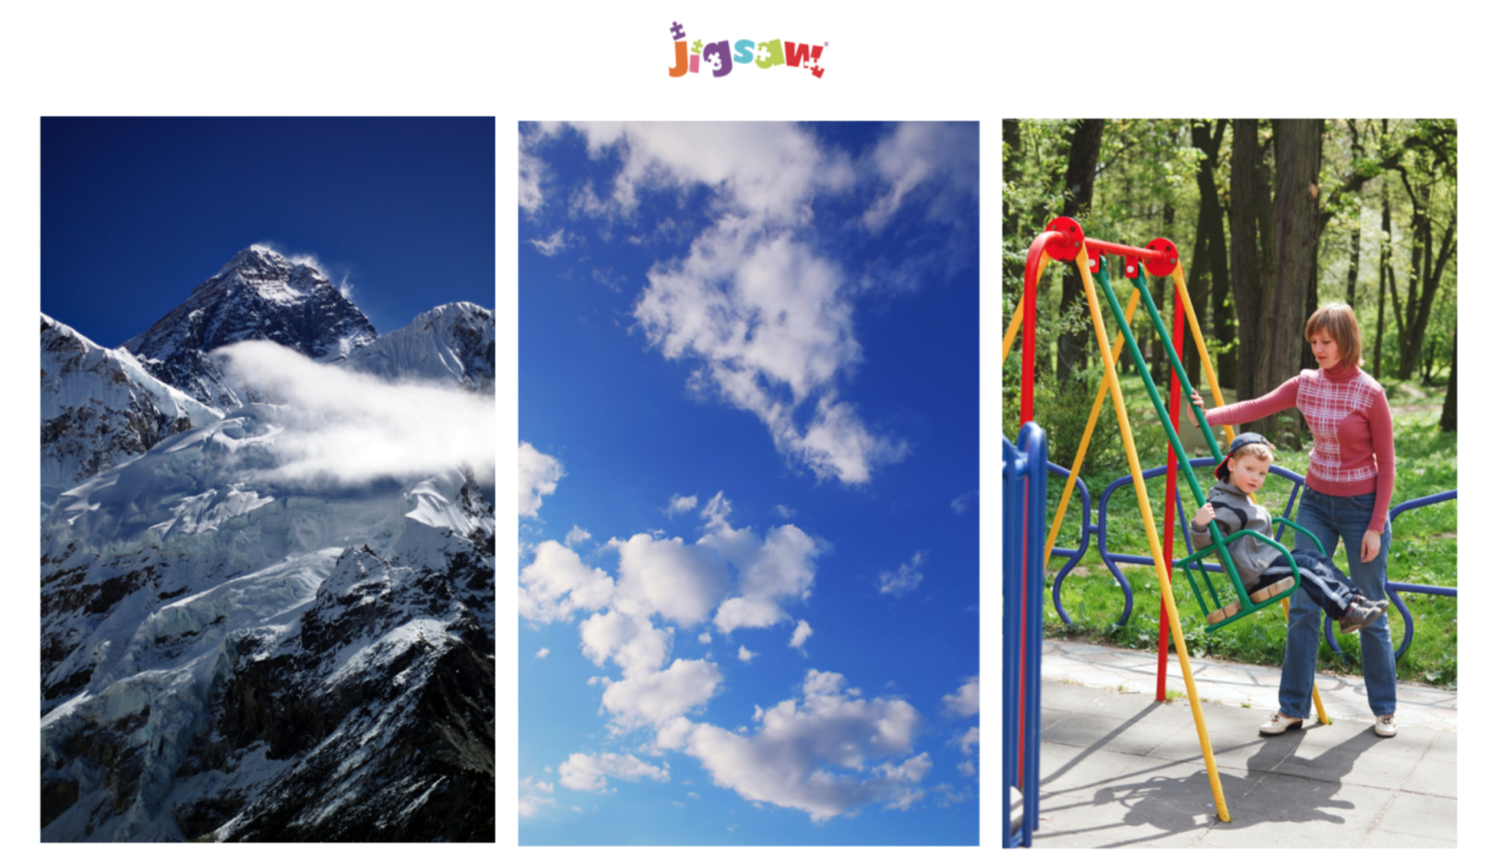
It is explained to the children that at the beginning of every Jigsaw lesson we will help our minds calm down so that we are ready to learn. We share the ‘Calm me’ pictures and children are encouraged to focus on their favourite picture. We share that to do the best learning we need calm, focused minds, and to help us with this we will use our breathing. The Jigsaw Chime is the start of our Calm Me exercise.

Children are invited to put both feet on the floor, sit up straight, but relaxed, and to have hands on their tummies. They can then close their eyes or focus on the calmest picture. The chime is shared and the children listen to it until the sound is all gone. We then take them through gentle breathing techniques: breathe in gently through your nose and let your breath sink all the way into your lungs, then gently let it out again through your mouth. Breathe in gently and out gently.
Can you feel your tummy rise as you breathe in and go back again as you breathe out?
This is repeated a number of times, encouraging the children to feel increasing calmness with each breath. The chime is shared again and the children listen until the sound is all gone, and then open their eyes and use their calm mind to help them learn.

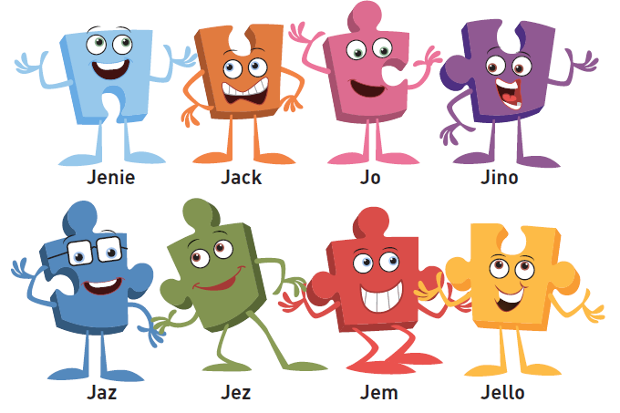
Jigsaw Friends

Each year group has their very own Jigsaw friend. The Jigsaw friends act as talking objects so the children are clear that when they are holding their friend, they can talk and be listened to.
Furthermore, the Jigsaw friends act as distancing tools to address learning about sensitive issues. For example, Jigsaw Jino has a problem in the playground and the children may be challenged to help find a solution for him.

